Multiple-choice section

|  |  |  |  |  |  |  |  |  |  |  |
| --- | --- | --- | --- | --- | --- | --- | --- | --- | --- | --- |
| Question | 1 | 2 | 3 | 4 | 5 | 6 | 7 | 8 | 9 | 10 |
| Answer | A | B | C | D | D | A | C | B | A | C |

Question 1 [7.1]

A

3*n* − 2 = 8

Question 2 [7.1]

B

4*c* + 5 = -11

LHS = 4(-4) + 5

LHS = -16 + 5

LHS = -11

LHS = RHS

∴ *a* = -4

Question 3 [7.2]

C

Where *x* = -1, *y* = 4.

Question 4 [7.2]

D

Where *y* = 0, *x* = 3.

Question 5 [7.2]

D

To obtain *x* ‘subtract 5 and multiply by 4’.

Question 6 [7.4]

A

3*x* + 5 = 2*x* + 7

3*x* − 2*x* = 7 − 5

*x* = 2

Question 7 [7.3]

C

 − 3 = 5

= 5 + 3

= 8

*b* = 8 × 5

*b* = 40

Question 8 [7.3]

B

2(*x* − 3) = 14

2*x* − 6 = 14

2*x* = 14 + 6

2*x* = 20

*x* = 10

Question 9 [7.4]

A

3*d* + 2 = 5*d* − 26

2 = 5*d* − 3*d* − 26

2 = 2*d* − 26

2*d* = 2 + 26

2*d* = 28

*d* = 14

Question 10 [7.5]

C

5*C* + 0.50 = 10.00

5*C* = 10.00 – 0.50

5*C* = 9.50

*C* = 

*C* = 1.90

An ice-cream costs $1.90.

Multiple-choice total marks: 10

Short answer section

Question 11 3 marks [7.3]

(a) Eleanor’s working  
 = 9  
  
 5*x* = 30  
 *x* = 6



(b)  = 9  
 5*x* − 6 = 18  
 5*x* = 24  
 *x* =  = 

(c) Eleanor should have multiplied by 2 before she added 6.

Question 12 3 marks [7.2]

At the start there is 30 L of water in the bucket.

5 litres drains out every 2 minutes.

Thus 2.5 litres drains out every minute.

It takes 10 minutes to empty the bucket.

Question 13 2 marks [7.1]

(a) 2*n* − 12 = 40

(b) 3*n* + 6 = 2*n* + 15

Question 14 4 marks [7.1]

(a) 4*x* − 3 = 9 (*x* = 3)  
LHS = 4 × 3 − 3  
= 12 − 3  
= 9  
= RHS  
Thus *x* = 3 is a solution.

(b)  = 18 (*x* = 3)  
LHS = ****≠ RHS  
Thus *x* = 3 is *not* a solution.

Question 15 2 marks [7.1]

Seven less than two times a number gives a result of fourteen.

Question 16 2 marks [7.1]

(a) *t* = *ds* (b) *v* = *u* + *at*

Question 17 2 marks [7.2]

2*x* + 1 = 9

2*x* = 8

*x* = 4

Question 18 4 marks [7.2]

(a) 3*b* + 2 = 14  
3*b* = 14 − 2  
3*b* = 12  
*b* =   
*b* = 4

(b) 13 + 4*d* = -27  
4*d* = -27 − 13  
4*d* = -40  
*d* =   
*d* = -10

Question 19 4 marks [7.2]

(a) *y* = 1 (b) *y* = 7

(c) *x* = 3 (d) *x* = 0

Question 20 4 marks [7.2]

(a) 4*a* − 5 = -17  
4*a* = -17 + 5  
4*a* = -12  
*a* =   
*a* = -3

(b)  + 2*x* =   
2*x* =  −   
2*x* =    
2*x* =   
*x* = = 

Question 21 3 marks [7.2]

(a) Let the cost of a sandwich be represented by the letter *s* and orange juice by the letter *j*.  
5*s* + 2*j* = 20

(b) 5*s* + 2(2.5) = 20  
5*s* + 5 = 20  
5*s* = 15  
*s* = 3  
So the cost of a sandwich is $3.00.

Question 22 6 marks [7.3]

(a)  = 7  
3*x* − 2 = 7 × 4  
3*x* − 2 = 28  
3*x* = 28 + 2  
3*x* = 30  
*x* =   
*x* = 10

(b)  + 7 = 3  
= 3 − 7  
= -4  
2*m* = -4 × 3  
2*m* = -12  
*m* =   
*m* = -6

Question 23 6 marks [7.3]

(a) 2(*x* − 3) = 16  
2*x* − 6 = 16  
2*x* = 16 + 6  
2*x* = 22  
*x* =   
*x* = 11

(b) 3(5*x* + 2) = 51  
15*x* + 6 = 51  
15*x* = 51 − 6  
15*x* = 45  
*x* =   
*x* = 3

Question 24 6 marks [7.3]

(a) 6*n* + 5 = 17  
6*n* = 17 − 5  
6*n* = 12  
*n* =   
*n* = 2

(b) + 7 = 10  
= 10 − 7  
= 3  
*n* = 3 × 5  
*n* = 15

Question 25 4 marks [7.3]

(a) string = 4*w* + 4*w* + 20  
string = 8*w* + 20

(b) 100 = 8*w* + 20  
8*w* = 80  
*w* = 10, so the width of the box is 10 cm

Question 26 3 marks [7.4]

2*x* + 8 = 6*x* + 4

4*x* = 4

*x* = 1

Question 27 6 marks [7.4]

(a) 6*x* − 5 = 4*x* + 5  
6*x* − 4*x* − 5 = 5  
2*x* − 5 = 5  
2*x* = 5 + 5  
2*x* = 10  
*x* =   
*x* = 5

(b) 2*x* + 1 = 5*x* − 14  
1 = 5*x* − 2*x* − 14  
1 = 3*x* − 14  
1 + 14 = 3*x*3*x* = 15  
*x* =   
*x* = 5

Question 28 6 marks [7.4]

(a) 5*x* − 2 = 3(*x* + 8)  
5*x* − 2 = 3*x* + 24  
5*x* − 3*x* − 2 = 24  
2*x* − 2 = 24  
2*x* = 24 + 2  
2*x* = 26  
*x* =   
*x* = 13

(b) 4(*x* + 4) = 3(2 − 2*x*)  
4*x* + 16 = 6 − 6*x*6*x* + 4*x* + 16 = 6  
10*x* + 16 = 6  
10*x* = 6 − 16  
10*x* = -10  
*x* =   
*x* = -1

Question 29 6 marks [7.4]

(a)  =   
2(4*x* + 3) = 3(*x* + 7)  
8*x* + 6 = 3*x* + 21  
8*x* − 3*x* + 6 = 21  
5*x* + 6 = 21  
5*x* = 21 − 6  
5*x* = 15  
*x* =   
*x* = 3

(b)  =   
5(12 − 2*x*) = 3(13 − *x*)  
60 − 10*x* = 39 − 3*x*60 = 39 − 3*x* + 10*x*60 = 39 + 7*x*60 − 39 = 7*x*7*x* = 21  
*x* =   
*x* = 3

Question 30 6 marks [7.4]

(a) 3 − *x* = 2*x*

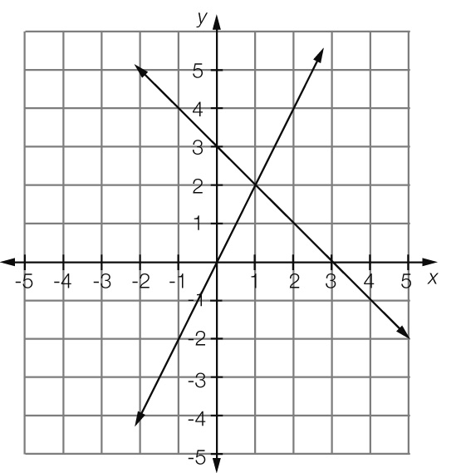

*x* = 1

(b) 2*x* − 3 = 3 − *x*

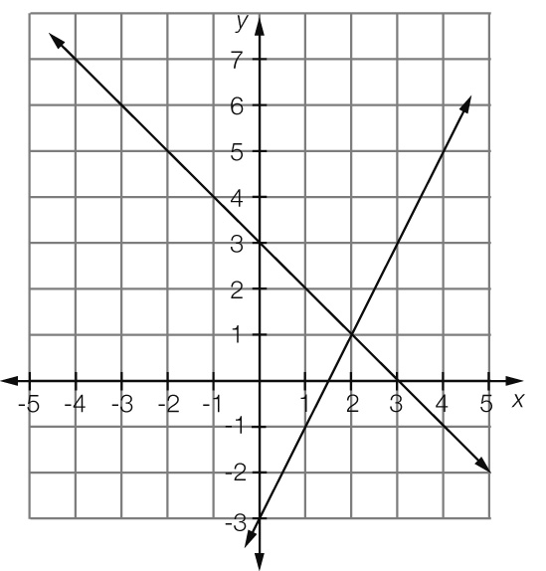

*x* = 2

Short answer total marks: 82

Extended answer section

Question 31 5 marks [7.2, 7.5]

(a) *C* = 0.6 + 0.15 × 6 × *n  
C* = 0.6 + 0.9*n*

(b) *C* = 0.6 + 0.9 × 8  
*C* = $7.80

(c) *C* = 7 × 0.6 + 67 × 0.9  
*C* = $64.50

(d) Total usage = calls + SMS  
 = 385 + (0.25 × 993)   
 = $633.25  
Charges = 50 + 633.25 − 600 = $83.25  
So, Aya’s bill for the month is $83.25.

Question 32 10 marks [7.3, 7.5]

(a)

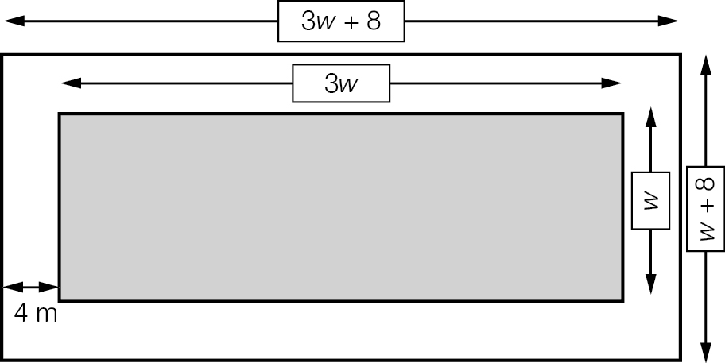

(b) *P* = 2(3*w* + 8 + *w* + 8)  
*P* = 2(4*w* + 16)  
*P* = 8*w* + 32

(c) 8*w* + 32 = 96  
8*w* = 96 − 32  
8*w* = 64  
*w* =   
*w* = 8  
Thus the width is 8 m and the length is 3 × 8 = 24 m.

(d) (i) *A* + *C* = 300, but there are twice as many children as adults so *C* = 2*A.*Replacing the *C* with 2*A* we get:  
*A* + 2*A* = 300  
3*A* = 300  
*A* = 100  
Thus there were 100 adults at the pool.

(ii) Number of children is 2 × 100 = 200  
Entry fee collection = 100 × 3.5 + 200 × 1.5  
= $350 + $300  
= $650

Extended answer total marks: 15

TOTAL test marks: 107